**If Tinder Existed to Find Your Perfect College Roommate**

It’s that time of year again: housing selection! It can be a pretty daunting process. You need to worry about selecting your first choice apartment, your future commute to campus, and most importantly, who you’ll be sharing your space with: your roommate. Unless you’re lucky enough to have formed an unbreakable bond with your freshman-year roommate, you’re probably on the hunt for someone who isn’t crazy, uptight, or extremely messy. Maybe your perfect friend likes to binge Netflix until 3am or parties all night. Whether you’re a homebody or a social butterfly, Tinder has just released a new feature! Instead of using the app for dating, it can now be used to find a roommate. Simply turn on your location services, select your school, and your class year. You’re required to put your living habits in your bio, of course. This is so you’ll be able to find someone who won’t drive you to get a single during open room change.

Swipe through some the first users of Tinder’s roommate setting!

***Valentina, 18***

[](http://hawkchill.com/wp-content/uploads/2018/02/Tinder-1.png)[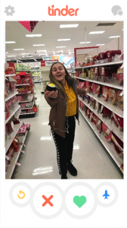](http://hawkchill.com/wp-content/uploads/2018/02/Tinder-2.png)

***0.4 miles away***

*Do you play ball? Cause I’m the catch of a lifetime*

*I’m a communications major with a passion for film and television. My weekends revolve around watching new films and ranking them in order from best to worst, so movie nights with me will always be interesting. Since my family is from Italy and Puerto Rico, it’s in my veins to love to cook, (and eat) especially typical Italian and Puerto Rican foods. I mean, I’m basically like that grandma that never lets you leave without being full. I also love to talk and have deep, meaningful conversations where we can discuss anything that’s bothering you. I also hate messes so rest assured that the house will be spotless 98.9% of the time. Finally, because I eat like there’s no tomorrow, I’m kind of a gym freak, which essentially means that you’ve got yourself a very encouraging, non-quitting, work hard, play harder gym buddy.*

*Swipe right for a very full belly and a very fun year.*

***Courtney, 22***

[](http://hawkchill.com/wp-content/uploads/2018/02/Tinder-3.png) [](http://hawkchill.com/wp-content/uploads/2018/02/Tinder-4.png)

***0.8 miles away***

*Do you like science? Because I got my Ion you.*

*My life revolves around biology. People call me bug girl, but that’s just because you can find me studying long hours in the lab. Sometimes, to make my weekends more fun, I like to bring home beakers and take shots from them. It gets really crazy. You could classify me as a party animal, especially when I start to pull experiments on my roommates. Some call them pranks, but I call it research!*

*I am habitually a peaceful roommate that prefers a sterile living environment. I typically operate on a nocturnal schedule, however I can tolerate a roommate who is an early riser. When I feed, I enjoy mozzarella sticks and anything spicy. Overall, I am a very cohesive roommate. If I’m not in the lab you can probably find me rock climbing. I just recently picked up this new hobby. I like to get out of the lab and try new things!*

*If you can “hang” with me, swipe right!*

***Jake, 19***

[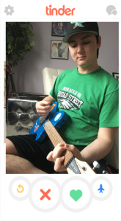](http://hawkchill.com/wp-content/uploads/2018/02/Tinder-5.png)[](http://hawkchill.com/wp-content/uploads/2018/02/Tinder-6.png)

***0.6 miles away***

*I’ll play guitar for you if you clean my room*

*I’m an Entertainment Marketing major and love all things music. I’m usually Face Timing my girlfriend, but when I’m not, you can catch me listening to records or playing my guitar. I’ve got both acoustic and electric, but I prefer the amplified sound. Music’s an essential part of me, and I’ve got a stereo system hooked up to my record player.*

*I’m usually up pretty late, working on assignments. Accounting 101’s always got me. I don’t really study much in my room, but it varies when I come home from the lib depending on the amount of work I’ve got.*

*I’m a heavy sleeper, I’ll sleep through pretty much anything. I’ve also been told that I snore, and I’ll sleep up until the minute I’ve gotta get out for class. I wouldn’t consider myself a dirty roommate. I don’t have trash lying around everywhere. But I really only put my clothes away after laundry day rolls around.*

*Swipe right if you’re laid back and into good music.*

***Anthony, 18***

[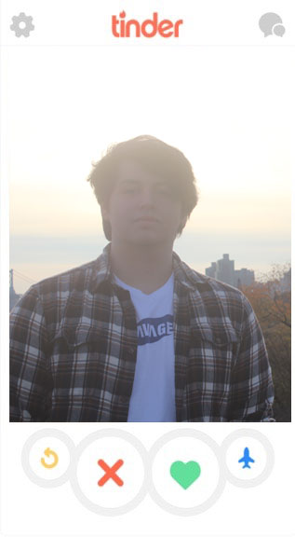](http://hawkchill.com/wp-content/uploads/2018/02/rispoli-tinder-1-.jpg)[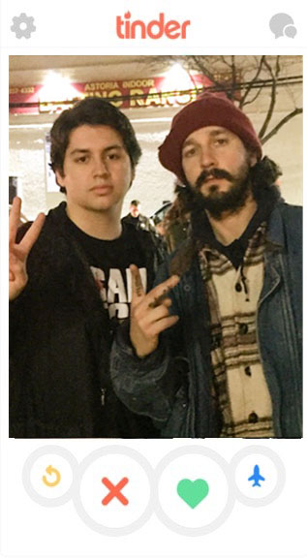](http://hawkchill.com/wp-content/uploads/2018/02/rispoli-tinder-2-.jpg)

***0.3 miles away***

*Mario is red. Sonic is blue. Press start to join and be my player 2.*

*I’m a communications major who enjoys photography and exploring. Anything you want to do in this city, I will tag along with you. Whether that’s a concert, eating out, or just trying new things, I’m down for it. Everything can be an adventure to me. All of my friends know that I can find some pretty cool spots to visit, but I’m also fun in the dorm. If you’re chilling in our living room, and you’re bored, I can bet my playlist will energize the room.*

*I’m into all kinds of music; rap, pop, folk, and rock. JUST PLEASE DON’T PLAY COUNTRY. I’m also a pretty easy guy to live with. I keep my side of the room clean, and I don’t care what you do with yours. Your life, your room, none of my business. I also like video games, so you can guarantee that our room will have a big TV.*

*Movies are one of my passions; new, old, and bad. Anything film related is guaranteed to be up my alley. Aside from all of my interests, I am a really easy guy to talk to and I am extremely understanding. (P.S. I personally know Shia LaBeouf.)*

*Swipe right if you want a relaxed roommate and an adventurous year.*

While there are some ideal roommates, and some not-so-ideal, hopefully you’ll be able to find your perfect match and live happily ever after!